**Programming with Java - Stacks**

**(1)** Which element of a stack has been in the stack the longest?

(a) The element at the bottom

(b) The element at the top

(c) The element in the middle

(d) All elements in a stack have been there the same amount of time

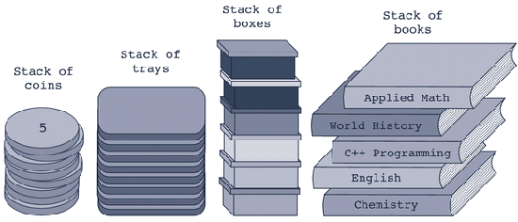

**(2)** Which operation would you use to return the Applied Math book from the stack above?

(a) top (b) push (c) pop (d) return (e) free

**(3)** What would the operation **isEmptyStack()** return if applied to the stack above?

(a) 0 (b) true (c) 5 (d) false (e) 1

**(4)** What would the pop operation do if applied to the stack above?

(a) Return the Applied Math book (b) Remove the Applied Math book

(c) Remove the Chemistry book (d) Nothing

**(5)** If you applied the operation pop to the stack above, which book would be left on top of the stack?

(a) Applied Math (b) Chemistry

(c) World History (d) English

**(6) public void operationX(DataElement newItem) throws StackOverflowException {**

**if(isFullStack())**

**throw new StackOverflowException();**

**list[stackTop] = newItem;**

**stackTop++;**

**}**

Which stack operation does **operationX** above define?

(a) top (b) push (c) pop (d) initializeStack

**(7) public DataElement operationY() throws StackUnderflowException{**

**if(isEmptyStack())**

**throw new StackUnderflowException();**

**DataElement temp = list[stackTop - 1].getCopy();**

**return temp;**

**}//end top**

Which stack operation is defined by **operationY** above?

(a) top (b) push (c) isEmptyStack (d) pop

**(8)** In an array - based stack, which of the following operations has a time - complexity of *O* ( *n* ) ?

(a) initializeStack **(b) deleteStack** (c) copyStack (d) constructor

**public class StackProgram {**

**public static void main(String[] args) {**

**StackClass intStack = new StackClass(50);**

**StackClass tempStack = new StackClass();**

**try {**

**intStack.push(new IntElement(23));**

**intStack.push(new IntElement(45));**

**intStack.push(new IntElement(38));**

**}**

**catch(StackOverflowException sofe) {**

**System.*out*.println(sofe.toString());**

**System.*exit*(0);**

**}**

**tempStack.copyStack(intStack);**

**System.*out*.print("tempStack elements: ");**

**while(!tempStack.isEmptyStack()) {**

**System.*out*.print(tempStack.top() + " ");// output 1**

**tempStack.pop();**

**}**

**System.*out*.println();**

**System.*out*.println("The top element of intStack: "**

**+ intStack.top()); // output 2**

**}**

**}**

**(9)** What is output 1 above?

(a) 23 38 45 (b) 38 45 23 (c) 38 23 45 (d) 23 38 43

**(10)** What is output 2 above?

(a) 23 (b) 45 (c) 38 (d) 50 (e) None of these

**Programming with Java - Queues**

**(11)** Whenever an application is modeled on a FIFO structure, __________ are used.

(a) lists (b) stacks (c) queues (d) arrays

**(12)** The method deleteQueue does which of the following?

(a) uses one queue to delete another

(b) removes the back element from the queue

(c) removes the front element from the queue

(d) removes all elements from the queue leaving an empty queue

**(13)** The method addQueue does which of the following?

(a) adds all the contents from one queue to another

(b) appends one queue to the back of another

(c) adds a new element to the front of the queue

(d) adds a new element to the rear of the queue